Connective Tissue
Connective tissues are widely distributed throughout the body of complex animals. They mainly help in connecting, supporting, binding, and protecting different tissues and organs. They range from soft tissues to highly specialized forms such as cartilage, bone, and blood.
In most connective tissues, the cells produce structural fibres made of proteins such as collagen and elastin. These fibres provide strength, elasticity, and flexibility. The cells also produce a substance that surrounds the cells and fibres, forming the extracellular matrix or ground substance.
Connective tissues are broadly classified into three types:
- Loose connective tissue
- Dense connective tissue
- Specialised connective tissue

I. Loose Connective Tissue
In loose connective tissue, the cells and fibres are loosely arranged within a semi-fluid ground substance.

Areolar Tissue
- Areolar tissue is commonly found beneath the skin and provides a supporting framework for the epithelium.
- It contains fibroblasts, macrophages, and mast cells.

Adipose Tissue
- Adipose tissue is mainly found beneath the skin and contains cells specialized for storing fat.
- Excess nutrients that are not immediately required by the body are converted into fat and stored in these cells, providing a reserve source of energy.
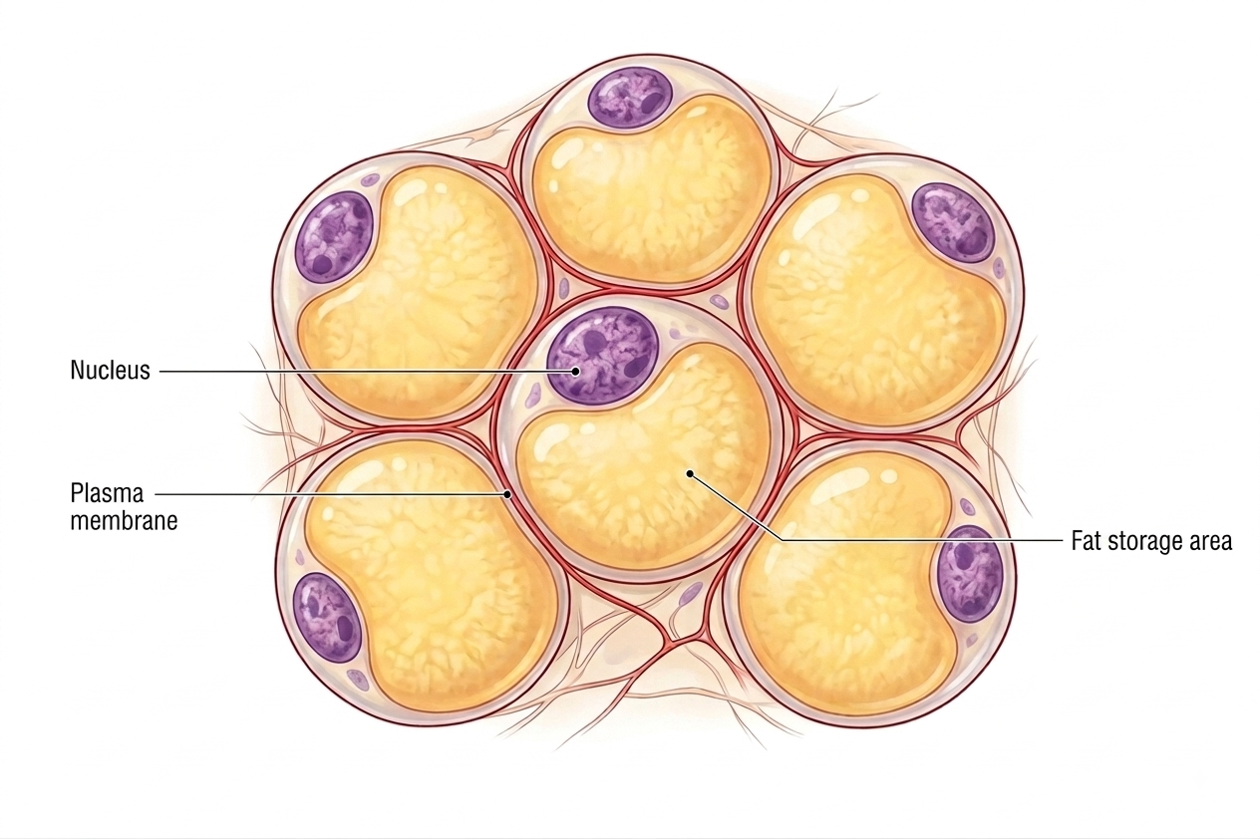

II. Dense Connective Tissue
In dense connective tissue, fibres and fibroblasts are closely packed. Based on the arrangement of the fibres, it is divided into regular and irregular connective tissue.

Dense Regular Connective Tissue
- The collagen fibres are arranged in parallel bundles, providing considerable strength.
Tendons
- Tendons are strong, fibrous structures that connect skeletal muscles to bones.
Ligaments
- Ligaments are elastic structures that connect one bone to another.
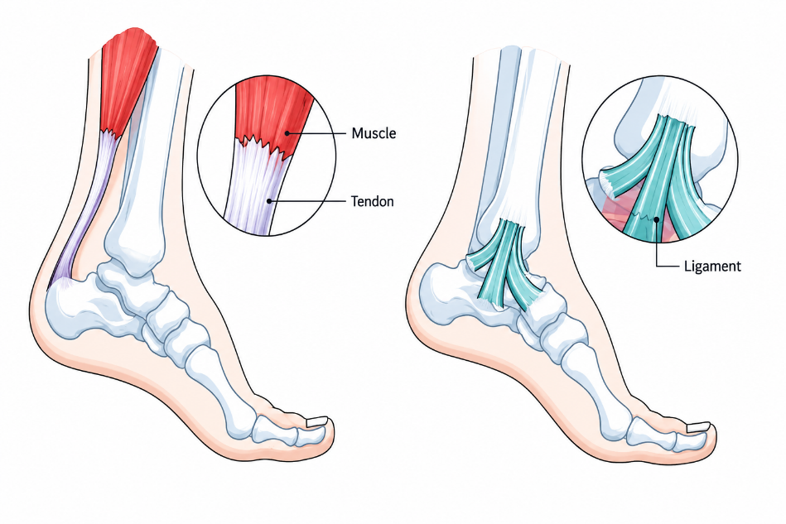

Dense Irregular Connective Tissue
- It contains fibroblasts and mainly collagen fibres arranged in different directions.
- It is mainly found in the skin.
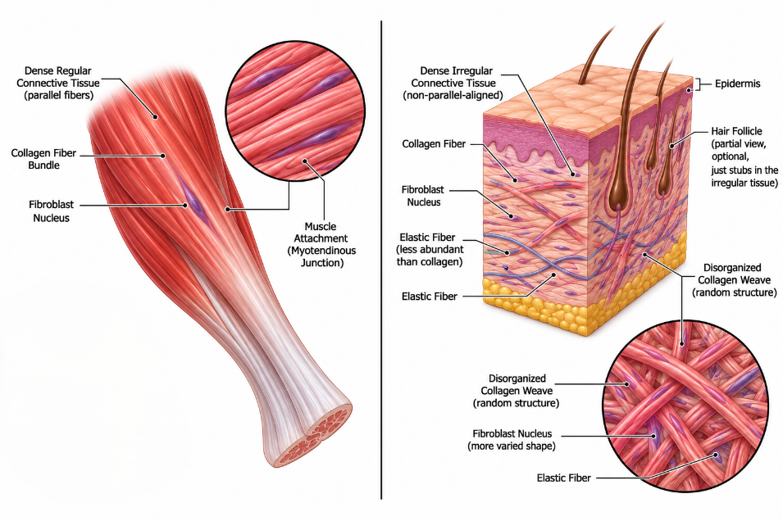

III. Specialised Connective Tissue
Specialised connective tissues include cartilage, bone, and blood, each adapted to perform specific functions.

Cartilage
- The intercellular matrix of cartilage is solid, flexible, and resistant to compression.
- The cells of cartilage are called chondrocytes. They are present in small spaces called lacunae within the matrix.
- Cartilage is present in adults at locations such as the tip of the nose, outer ear, joints, limbs, hands, and between adjacent vertebrae.
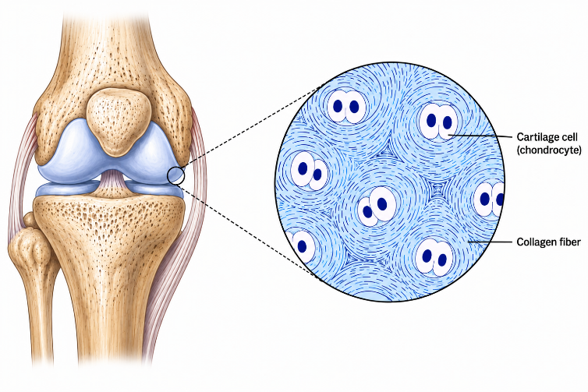

Bone
- Bone has a hard and non-flexible matrix containing calcium salts and collagen fibres, which provide strength.
- It forms the main structural framework of the body and supports and protects internal organs.
- Bone cells, called osteocytes, are present in spaces called lacunae.
- Limb bones support the body and work with skeletal muscles to produce movement.
- The bone marrow present inside certain bones is involved in the production of blood cells.
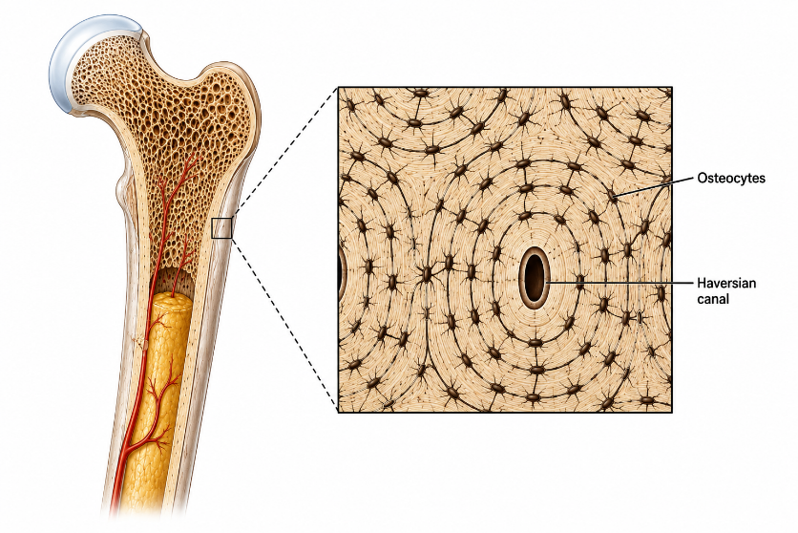

Blood
- Blood is a fluid connective tissue that transports various substances throughout the body.
- Unlike most other connective tissues, its cells do not produce structural fibres.
- Blood consists of plasma and cellular components.
Red Blood Cells (RBCs) / Erythrocytes
- RBCs contain haemoglobin, which helps in the transport of respiratory gases.
- In frogs, RBCs are nucleated.
White Blood Cells (WBCs) / Leucocytes
- WBCs play important roles in defence and immune responses.
Platelets
- Platelets are cell fragments that play an important role in blood clotting.
